Network Analysis Summary
To look beyond flat data and to understand connections and tie strength between various members, adapted network visualization graph techniques and network centrality metric techniques to identify each member affiliation relationship, importance and interactions and as well as weak and strong connections within the network. The following table portrays centrality and tie metrics summary of various members in S1-79 meeting
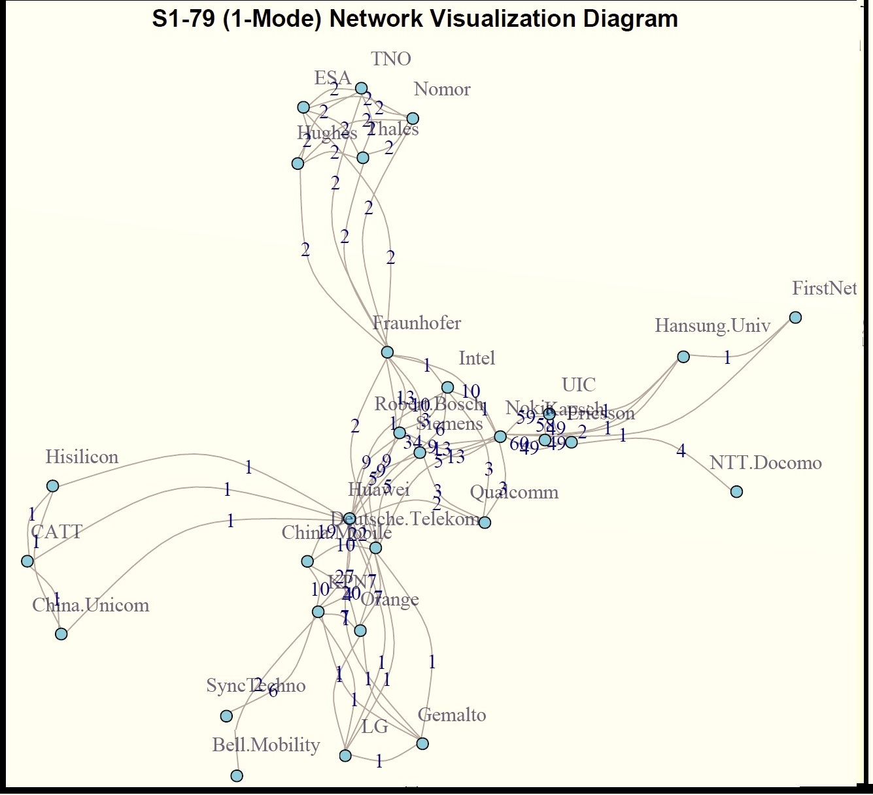
Nokia has maximum ties of 225 with other members thereby standing out as an important member in the networks of S1-79. Excel gives complete list of each members ties strength with others in the network.
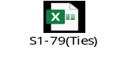
The metrics signifies that

- Nokia is the most prominent and influential member because most central in the network with closer access to reach other members in the network resulting new partnerships. Possesses high control on the communication flow and with maximum tie strength in the network, Nokia tend to spend more time with members resulting much stronger tie-up with various groups in the network.

